Shrewsbury Health and Wellbeing Hub – Patient and Public Advisory Group Terms of Reference Purpose This Patient and Public Advisory Group (PPAG) has been formed to support the communications, engagement and consultation activities relating to the proposals for a health and wellbeing hub in Shrewsbury. Members will represent their practice or organisation and will give their views on communications and engagement plans and materials relating to this project to ensure that all relevant public and patient groups are involved, that our work takes the needs of different groups into account and that our communications materials are accessible and easy to understand. Members will also have an opportunity to review the feedback given as part of our public and patient involvement work and to comment on it. Membership • The PPG chair, or another patient representative, from the 8 GP practices involved with this project • Voluntary sector organisations working with people from one of the nine protected characteristics and/or those who are who are most likely to access GP services • Health watch Shropshire Meetings – frequency and duration It is planned that four online meetings will take place during the pre-consultation engagement and consultation phases of this project. 1) At the start of the pre-consultation engagement phase (end Aug/early Sept 2021.) 2) At the end of the pre-consultation engagement phase (mid Oct 2021) 3) In the middle of the consultation phase (mid Nov 2021) 4) At the end of the consultation phase (January 2022) It is envisaged that the meetings will last for approximately 1.5 hours. All feedback given at the meetings will be noted and will feed into the project work. The meetings will be managed and chaired by the Arden GEM CSU engagement team

Disability History Month takes place between 18 November and 18 December 2021 and celebrates the lives and achievements of people living with a disability.

Claremont Bank Surgery Newsletter
October to December

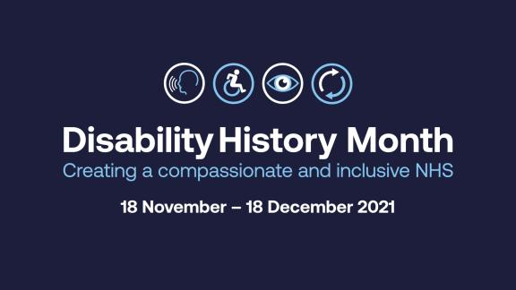

Patient Transport

Patient Transport (NEPTs)
E-zec Medical Transport Services (E-zec) took over the provision of Non-emergency Patient Transports (NEPT) Service from 1 October.

It will supply services for residents of Shropshire, Telford and Wrekin.

A Non-Emergency Patient Transport (NEPT) Service is provided for patients who:

Have a medical condition which prevents them from using other forms of transport to travel to and from healthcare appointments
Escorts for patients who have a medical need for an escort such as a parent travelling with a child or a carer/health professional traveling with someone who has a learning disability or mental health illness
This service is separate from the emergency ambulance service and is not provided to people who require transport for social or financial reasons, or for those who are able to travel on public transport or by other means to get to their healthcare provider.

To be eligible to use this service patients must:

Be registered with a GP in Shropshire or Telford and Wrekin
Have been referred for treatment to a hospital or another medical establishment
Patients will be assessed on their eligibility.
If a patient is eligible, they can book transport as a patient, or as a patient’s nominated representative, by calling 0300 7770077 (8am to 6pm, Monday to Friday).
For more information please visit the CCG website.

Talking about grief

Whilst many of us are getting ready to celebrate Christmas with our loved ones, for some this is a painful reminder of someone they have lost. This Grief Awareness Week (2 to 8 December), a group of local patients and health and care staff have come together to raise awareness about the grieving process and what we can do to support those living with grief.

The ‘Growing the Conversation’ group, set up by Shropshire, Telford and Wrekin CCG to encourage people to talk about end of life care, recognises the importance of talking openly about death and dying, both for the individual and their family, but also the needs of those left behind grieving a loss.

People are invited to join an online event on Thursday, 2 December, from 3.30pm to 5pm, where a panel of local specialists will share what grief means to them, answer questions about grief, talking about death and dying, and supporting people who are grieving. Panel members will include representatives from the Samaritans, Prism Community Bereavement Service, General Practice and the faith community, and everybody is welcome.

There is also a grief awareness session taking place on the Mark Elliot BBC Radio Shropshire show from 7pm on Thursday 2 December where he will be joined by special guests, including Dr Derek Willis and Dr Julia Head.

Alison Massey, leading on the CCG’s review of End of Life Care, said: “I’m really inspired that the ‘Growing the Conversation’ group has been driven by people who have personal experience of end of life care and grief. Through our End of Life Care Review, which has involved working with our local health and care organisations and patients to improve the care that people receive, we recognised the importance of talking about death, dying, and grief. It is too often seen as a taboo subject but it’s so important that we have these conversations with friends, loved ones and people that care for us.”

FRIENDS AND FAMILY
[Type a quote from the document or the summary of an interesting point. You can position the text box anywhere in the document. Use the Drawing Tools tab to change the formatting of the pull quote text box.]
[Type a quote from the document or the summary of an interesting point. You can position the text box anywhere in the document. Use the Drawing Tools tab to change the formatting of the pull quote text box.]
[Type a quote from the document or the summary of an interesting point. You can position the text box anywhere in the document. Use the Drawing Tools tab to change the formatting of the pull quote text box.]

Here are the last 3 months results for friends and family. This is when patients let us know how their experience was at the surgery and let us know how likely they are to recommend us to friends and family.

Please see figures from July, August and September 2020.

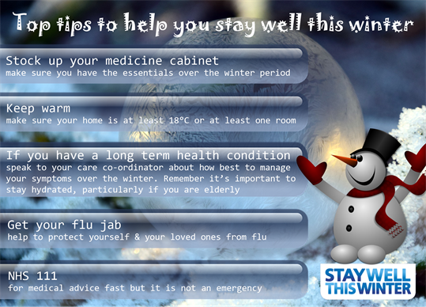
Keep your home warm
Follow these tips to keep you and your family warm and well at home:
- if you're not very mobile, are 65 or over, or have a health condition, such as heart or lung disease, heat your home to at least 18C
- keep your bedroom at 18C all night if you can – and keep the bedroom window closed
- if you're under 65, healthy and active, you can safely have your home cooler than 18C, as long as you're comfortable
- use a hot water bottle or electric blanket to keep warm in bed – but do not use both at the same time
- have at least 1 hot meal a day – eating regularly helps keep you warm
- have hot drinks regularly
- to reduce the risk of sudden infant death syndrome (SIDS), babies should sleep in rooms heated to between 16C and 20C
- draw curtains at dusk and keep doors closed to block out draughts
- get your heating system checked regularly by a qualified professional

December/Christmas

Christmas opening hours at Claremont Bank Surgery are yet to be confirmed however if you follow our Facebook we will be putting regular updates on or alternatively you could check our surgery website for updates.

Outside surgery opening hours you will always be able to contact NHS 111 for non-urgent medical advice. You can contact them online or by dialling 111 on your phone. This service is available 24 hours, 7 days a week. If you have a medical emergency always phone 999.

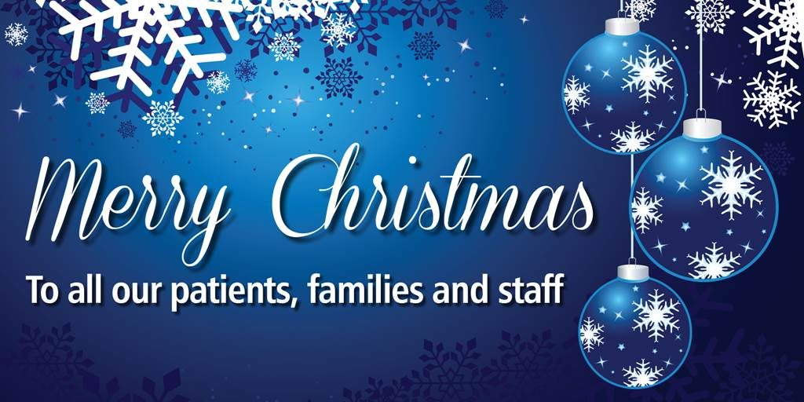

One year on Shropshire, Telford & Wrekin Covid-19 Vaccination Service celebrates over 920,000 vaccines

One year since the COVID vaccination roll out across Britain, Shropshire, Telford and Wrekin’s first patient to be vaccinated, Stephen Bridgwater, has praised workers for their efforts in helping to protect the public from the virus.
Stephen, from Edgebold, had his vaccine on 11 December 2020. The 90-year-old said: “It was a big surprise when I received the phone call telling me I was invited to have my Covid vaccine, a huge wave of relief passed over me."
Since then, Shropshire, Telford & Wrekin Covid-19 Vaccination Service has administered over 920,000 vaccines, an amazing achievement we should all be proud of.

